
Unitarian Universalist
Fellowship of Lafayette

Greetings fellow UUs and supporters!

We are meeting IN PERSON
and on Zoom until further notice.

Our theme for March is Trust.

Trust is fundamental to a good life. It is the key to faith, an element of covenant, and the basis of promise-making and promise-keeping. It is to trust others and to be trustworthy. Trust is built on truth and destroyed by lies. Trust always involves risk since it can be broken. Restoring trust after a betrayal is especially difficult and can impair the willingness to trust. Responding to betrayal can involve healing and forgiveness, but not forgetting.
—
Sunday, March 26th Service

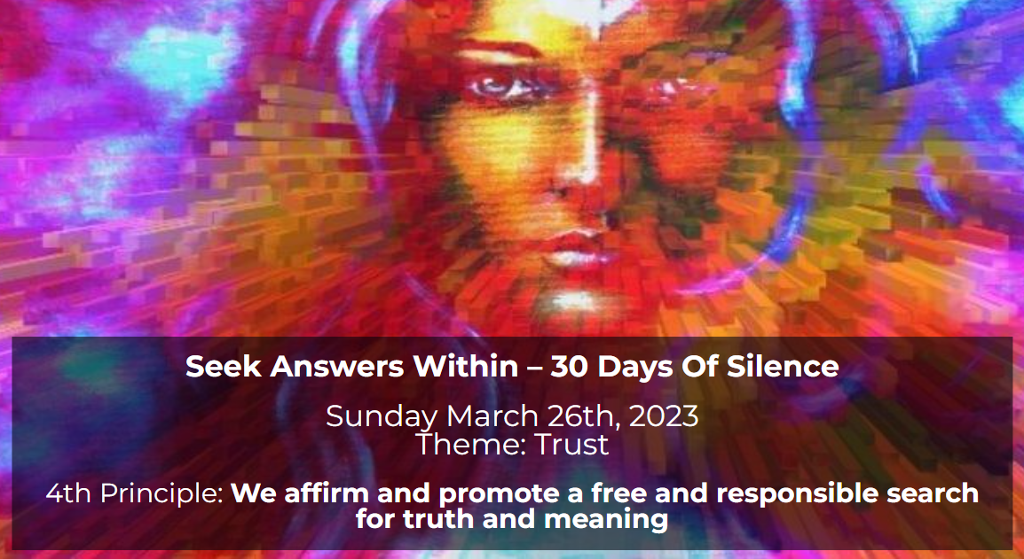

This service features a presentation by Marlene Lucas which includes recalling a meditation retreat in India. Marlene has extensive expertise in Psychiatric and Addictive Medicine Services. She also speaks and trains on addictions and recovery, grief and loss support, coping and therapeutic interventions for trauma .

Service outline

Service slides

Facebook event

Please visit us either in person at 1119 Johnston St. or on Zoom: tinyurl.com/zoomuufol or via the link at uulala.org.
We now have Religious Education for pre-teen children. We visit with coffee and snacks from 10:30-11 am. The service runs from 11 am until 12 noon. After the service we will have an Americana lunch with Frito pies and chili dogs (including vegetarian options) at church. Everyone is invited!
—
Sunday, March 19th Service


This sermon is about getting help when you need it. Seeking and asking for help requires trust. Addie Polk's health declined after her husband died, and she neglected or was unable to continue paying the mortgage on her home. The mortgage was foreclosed on. On the day that sheriff's deputies came to evict her, she shot herself, but recovered. She was placed in a nursing home where she died the following year. It is important that we, as Unitarian Universalists know how to look for the warning signs of depression, anxiety, substance abuse, or compulsive behaviors in ourselves and others. It is also important that we know when it is time to ask for help when we need it. Rather than giving up, there may be solutions to our problems if we are willing to look for them. We need to learn to manage worry in healthful ways and remember that we are not alone.

Service outline Service slides

Sermon text
—
Useful Links:

Past services slides & Recorded live streams

2022 Photo album
—
Announcements:

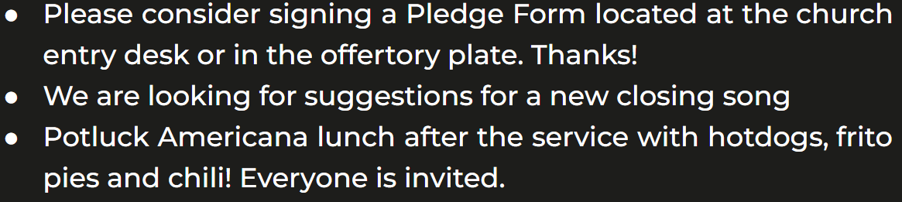

Membership Book:

Please sign the 2023 Membership Book on the table at the church entrance. Thanks!

Newly Elected Officers:

Congratulations to President Lauren Dupuis, Vice President Judi Hamilton, Secretary Amber Faul, and Treasurer Bruce Snow!
—
Calendar:

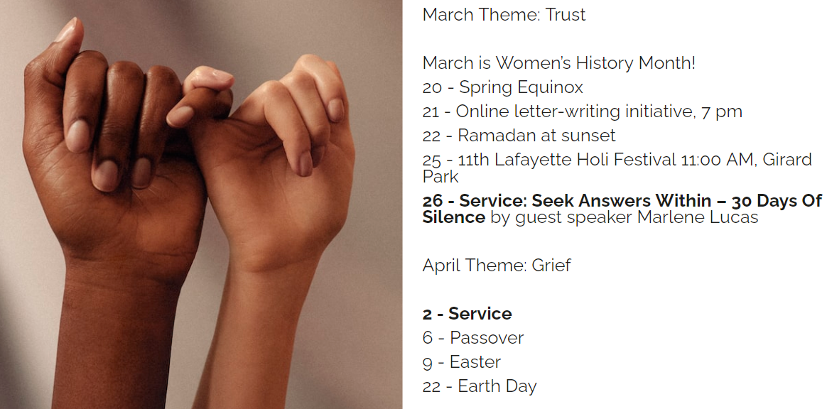
​—
Touchstones Journal for March:

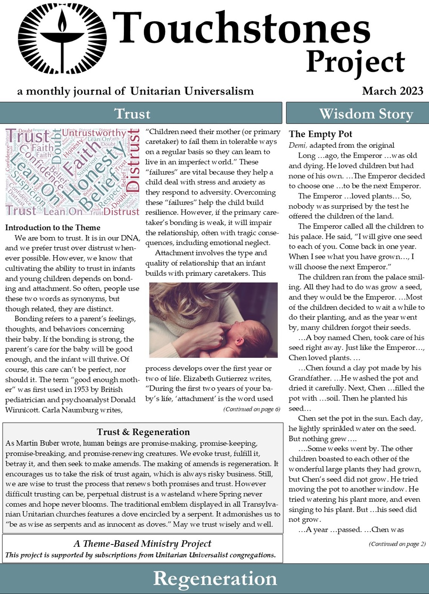
PC users click the image above.
Phone users click here:
Read the Journal now!
—
Have a great week!
Scott Ferguson, Services
Web: uulala.org

Email: uulalafellowship@gmail.com

Facebook: facebook.com/uufol

You Tube: youtube.com/@uufol
—
END

